Design Patterns – Ana Gadelha 59943
Class Location:
ganttproject/src/main/java/net/sourceforge/ganttproject/task/TaskContainmentHierarchyFacade.java
This design pattern is a Façade. What provides a simplified interface to a set of interfaces in a subsystem, therefore it hides the complexities of the subsystems.
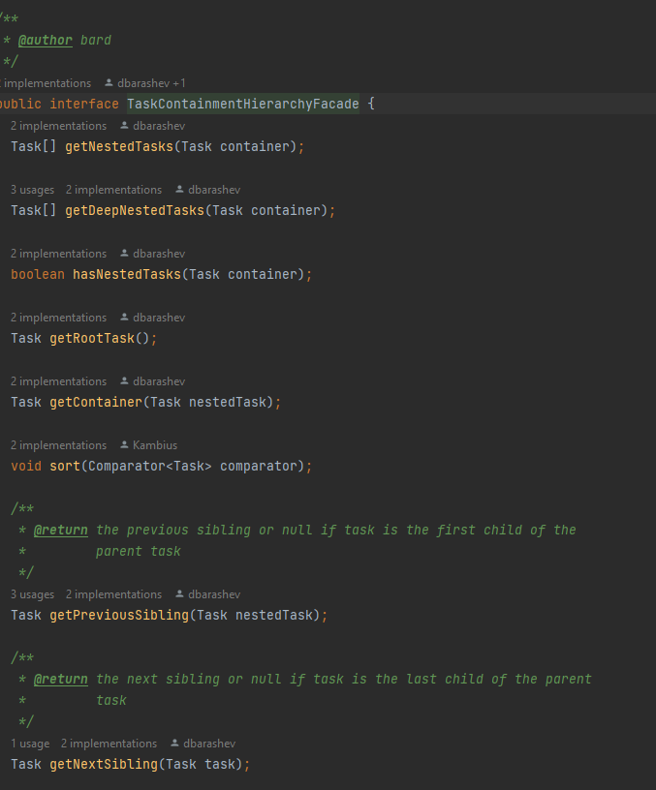

Class Location:
ganttproject/src/main/java/net/sourceforge/ganttproject/parser/ParserFactory.java
ganttproject/src/main/java/net/sourceforge/ganttproject/GanttProject.java
This design pattern is a Factory Method. It defines an interface class for creating an object but it lets the subclasses decide which class to instantiate.
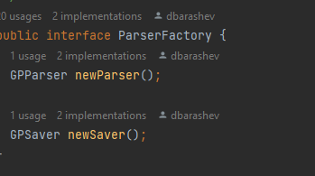
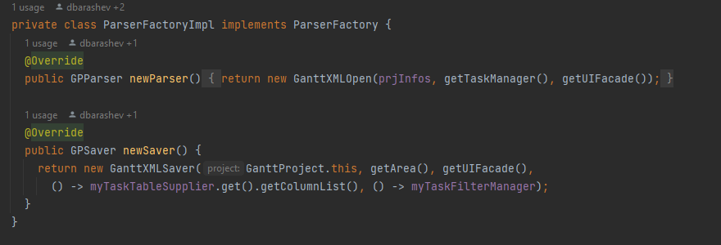
Class Location:
ganttproject/src/main/java/net/sourceforge/ganttproject/GanttOptions.java
This design pattern is a Singleton, because this class has only one instance and it provides a global point of access to it.
